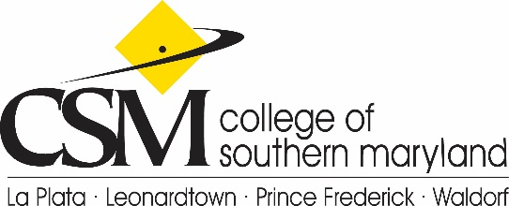news
Community/Media Relations, P.O. Box 910, La Plata, MD 20646 http://news.csmd.edu
Karen Smith Hupp, Assistant Vice President,PIO, Desk: 301-934-7701, Cell: 240-682-7022, karens@csmd.edu
Dorothy Hill, Senior Media Relations Coordinator, Desk: 301-934-7745, Cell: 240-419-0997 dmhill@csmd.edu
http://twitter.com/CSMHeadlines

FOR IMMEDIATE RELEASE
February 4, 2016

w/Photo/Calendar

Tri-County Job Fair Employer Registration through March 28
April 5 Event to Match CSM Graduates, Community Members with Area Jobs

On April 5, the College of Southern Maryland will host the Tri-County Job and Career Fair at the La Plata Campus. Registration for employers wishing to participate is open through March 28 at www.csmd.edu/JobFair.
This year’s fair, from 10 a.m. to 2 p.m., will require advance registration and includes a “Ready Room” for job seekers.
"Career Services is excited to host a ‘Ready Room’ during the weeks leading up to the Job and Career Fair. A visit to the Ready Room can result in an outstanding resume, knowing just what to say to recruiters and projecting an overall professional image. We want to help every job seeker be their absolute best and get the job they want," said Career Services Senior Associate Director Lisa Warren.
The new location for the fair will be in the Center for Business and Industry (BI) Building.
For information on Career Services at CSM, visit http://www.csmd.edu/student-services/advising/career-services/index.html.
Caption
15JobFair-8182.jpg
The 2016 Tri-County Job and Career Fair will be at the College of Southern Maryland Center for Business and Industry (BI) Building on the La Plata Campus April 5.

Calendar
Tri-County Job & Career Fair Employer Registration. Through March 28. Employer Registration is underway for the Tri-County Job and Career Fair 10 a.m. to 2 p.m., April 5, College of Southern Maryland, La Plata Campus, Center for Business and Industry (BI) Building, 8730 Mitchell Road, La Plata. Employers can directly recruit students and residents of the community to fill current and future job openings. $175 through March 28. www.csmd.edu/JobFair, call 301-934-7574 or email CareerServices@csmd.edu.

Tri-County Job and Career Fair 2016. 10 a.m. to 2 p.m., April 5. College of Southern Maryland, La Plata Campus, Center for Business and Industry (BI) Building, 8730 Mitchell Road, La Plata. Job seekers will have the opportunity to meet with employers in areas ranging from information technology and healthcare to hospitality and government. Attendees are encouraged to wear professional interview attire and have plenty of resumes. Free to all job seekers; registration is required. Visit the “Ready Room” prior to the event for resume and interview support. www.csmd.edu/JobFair, 301-934-7569 or CareerServices@csmd.edu.
###

