Calvert County Commission for Women (CCCW) Presents------
Networking & Conversation... Join us! Let’s Talk! Bring A Friend!
Information exchange so bring your business cards.

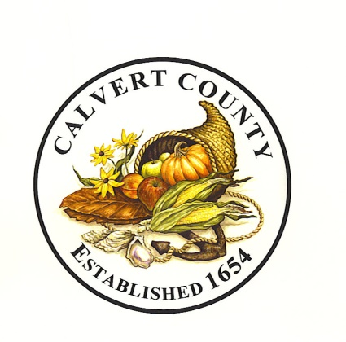
Where: Calvert Library Southern Branch. 13920 H G Trueman Road. Solomons, MD 20688
410-326-5289. Located in shopping center next to Holiday Inn Solomons

Time: 7:00 pm to 8:30 pm (Light refreshments served.)

When: Monday, March 21, 2016

Purpose & Mission of CCCW
The Calvert County Commission for Women was established by the Calvert County Board of County Commissioners by Resolution on June 22, 1976. Its purpose and mission is to focus on women’s concerns to: Develop opportunities for women; Eliminate barriers; Give recognition; Frame issues; Identify problems and recommend solutions; Enhance economic self-sufficiency; Promote security & safety; Empower women; Advocate; and Act as an Information Clearing house.

Members of the Calvert County Commission for Women are: Chair Margaret Dunkle; Vice Chair Annette Funn; Inez Clagett; Sonya M. Butler; Suzanne Haynes; Ariane Swann Odom; Belinda Battle; Gloria Della; Shelley Downie; Lisa Sarafino; Sara Shaffer.

The Commission is seeking new members. You may contact us at 410-535-1600 and 301-855-1243 to request a membership application. CCCW meets monthly on the 3rd Thursday.

1976-2016 Calvert County Commission for Women: 40 Years Serving Calvert Women & Girls.

Updated February 2016

