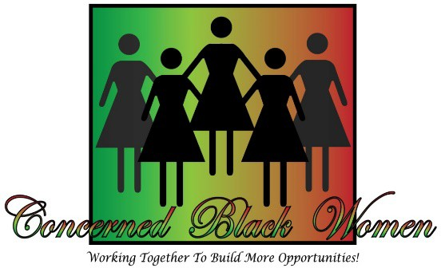

Dear Sponsors:
General Advertisement Form 2019

The CBW Salute to Excellence Awards and Scholarship Fundraiser Luncheon will be held at the Bethel Way of the Cross Church of Christ, Inc. located at 5450 Cherry Hill Road in Huntingtown, Maryland, 20639 on Saturday, October 12, 2019, from 11:00am-2:30 pm. This is your opportunity to support our fundraiser and market your business through advertisement in the event’s Souvenir Program Book. Your sponsorship advertisement will be used to fund scholarships for local students. CBW is a 501(C) 3 non-profit organization. Thank you for your support.
Ads can be submitted in either color or black and white, JPEG or PDF format, no later than the deadline of Friday, September 6, 2019. Advertisers assume liability for the content of advertisement printed and will assume responsibility for all clients that may arise from their ads.

AD SIZE | PRICES | SIZE | FORMAT
FULL PAGE | $225 | 8” x 10” | PDF or JPEG FORMAT
HALF PAGE | $125 | 8” x 5” | PDF or JPEG FORMAT
QUARTER PAGE | $75 | 4” x 5” | PDF or JPEG FORMAT
BUSINESS CARD  (1/8 page) | $50 | 4” x 2” | ACTUAL CARD OR  PDF OR JPEG FORMAT
PATRON PAGE  *Name Printed on Page | $5 |  | NAME AS IT SHOULD APPEAR

Contact Name:

Business/Organization:

Title:

Address:

City: State: Zip Code

Phone: Fax:

Email:

Authorizing Signature:

Check below the type of advertisement.
Full Page $225 Half Page $125 Quarter Page $75 Business Card $50 Patron Page $5

Make all checks payable to: CBW, and mail to: Concerned Black Women Calvert County (CBW), Post Office Box 927, Prince Frederick, Maryland 20678. The advertisement deadline is: Friday, September 6, 2019.

Advertisement information contacts:
General Ads & Corporate Sponsorship Ads: CBW, President at CBWofCC@gmail.com or 443.550.1229

