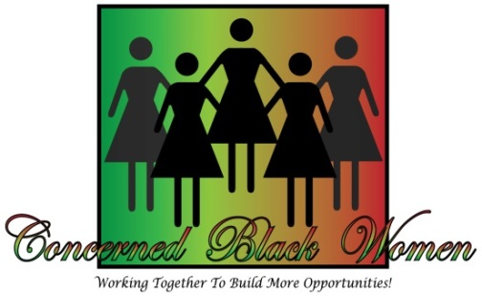

Community Partner, Sponsor, and Friend:
It is with great pleasure that I offer your organization a great opportunity to become a valuable “Champion Scholarship Sponsor” of our upcoming fundraiser. The Concerned Black Women (CBW) of Calvert County will host its 12th Annual Salute to Excellence Awards and Scholarship Fundraiser Luncheon on Saturday, October 12, 2019, from 11:00 am - 2:30 pm, at the Bethel Way of the Cross Church of Christ located at 5450 Cherry Hill Road, Huntingtown, MD 20639.

During the luncheon we will proudly salute and honor African American Women of Excellence in Calvert County. Awards will be presented for the following categories: Annette J. Funn Community Excellence Award, Dr. Doris Cammack-Spencer Co-Founder Award, Madam C.J. Walker Business Award, Myrtle M. Patten Health Award, Harriet Elizabeth Brown Education Award, Ailene Stamper Youth Award and the Harriet Tubman Woman of the Year Award. Enjoy a delicious lunch, networking and entertainment all for a worthy cause, as CBW works to build better communities for the citizens of Calvert County Maryland.
Money raised will benefit our scholarship fund. Each spring we select a graduating senior, one from each of the four public high schools. CBW is a 501 (c) (3) non-profit organization and in our 11-year history, we have raised $76,000 and helped 49 deserving seniors reach their goal of academic excellence. CBW mentors its scholarship winners, so the recipients are able to reap benefits far beyond the money they receive. Through the generous contributions of many sponsors, supporters, and friends like you, CBW hopes to continue supporting the educational goals of the youth in our community.
As a valuable sponsor, you will receive special reserved seating and recognition at the luncheon, prominent acknowledgement in the souvenir program, and you will be showcased on the CBW website for 1 year.

More details of the total amount necessary to become a sponsor are given in the enclosed document. Please submit all donations by Friday, September 6., 2019. Make checks payable to CBW; mail to P.O. Box 927, Prince Frederick, MD 20678. See attached Sponsorship Form 2018 for additional information.

Becoming a “Champion Scholarship Sponsor” will help four more graduating seniors pay for college. Together we are changing lives and building brighter futures. Thank you so much for your support. If you have additional questions about this wonderful opportunity, please contact me at cbwpres@gmail.com or 443-550-1229.
Sincerely,
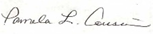
Pamela L. Cousins
President

