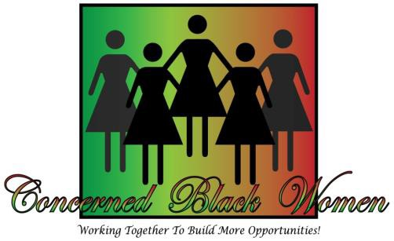
Sponsorship Form 2019

A Salute to Excellence
Awards & Scholarship Fundraiser Luncheon
Saturday, October 12, 2019
11:00 am - 2:30 pm
Bethel Way of the Cross Church of Christ, Inc.
Huntingtown, MD 20639

Enjoy an inspiring event as CBW works to build better communities
for all in beautiful Calvert County, Maryland!

Be a Champion Scholarship Sponsor!

- Receive special reserved seating at the Luncheon
- Recognized during the Luncheon’s opening Celebration
- Acknowledgement in the Souvenir Program with Logo & web address
- Listed on CBW web page for 1 year: until October 2019
- Prominent company name and Logo displayed on back inside cover
OR back cover page in the Luncheon Souvenir Program

Please check your level of Champion sponsorship:

- PLATINUM CHAMPIONS LEVEL $5,000 (5 free tickets)
- GOLD CHAMPIONS LEVEL $2,500.00 (3 free tickets)
- SILVER CHAMPIONS LEVEL $1,000.00 (2 free tickets)
- BRONZE CHAMPIONS LEVEL $500.00 (1 free ticket)

Sponsorship Deadline: Friday, September 6, 2019

CONTACT: CBW President for Corporate Sponsorship, Program Ads or Tickets at 443.550.1229.
Mail checks payable to CBW: P. O. Box 927, Prince Frederick, MD 20678
A non-profit 501(C)(3) organization. CBW website is www.concernedblackwomencalvertcounty.org

