Barstow Acres Children’s Center, LLC
Awarded FY 21 MOTA Grant
Calvert HEED (Help Educate to Eliminate Diabetes
Funding from the Minority Outreach and Technical Assistance Grant (MOTA) is providing awareness, screenings, and prevention programs to help combat health disparities, specifically the high number of minorities in Calvert County with Diabetes (Type II) w/ emphasis on mental health. | REGISTRATION  INFORMATION  To register click on the link:  Cbpseminars.org  Go to Homepage, then calendar to the date of the training and click on the link  For inquiries send e-mail:  barstow.acrescc@yahoo.com  Office #: 410-414-9901  Grant Director:  Sonia Hinds – cell: 240-535-1433  ALL PARTICIPANTS WHO REGISTER, COMPLETE ASSESSMENT AND ATTEND WEBINARS WILL BE ELIGIBLE FOR A DISCOUNTED MEMBERSHIPS AT RESULTS FITNESS.  EACH WEBINAR WILL PROVIDE A CHANCE FOR PARTICIPANTS TO WIN A $25.00 Gift Card.  FOR MORE PROGRAMS INFORMATION VISIT https://childrencenter.net/

FREE WEBINAR SERIES
#1 October 27, 6-7:30 PM

Introduction of the MOTA Grant & Staff
Brief Self-Assessment/ Diabetes: Risk Factors for Stress, Anxiety
& psychosocial aspects contributing to non-compliance

Diabetes Across the Lifespan: What you Need to Know
Sonia Hinds & Joshua Goldberg

#2 November 18, 6-7:30 pm
Diabetes: The Effects of Stress, Anxiety & Depression on the Family
Sonia Hinds & Goldberg Family

#3 December 15, 6-7:30 pm
Diabetes: Parenting a Child with Diabetes: Impact on the Family
& Parenting Strategies
Sonia Hinds & Goldberg Family

#4 January , 6-7:30 pm
Diabetes: Impact on Education and Role of Spirituality
Sonia Hinds, School Nurse, Spiritual Leader
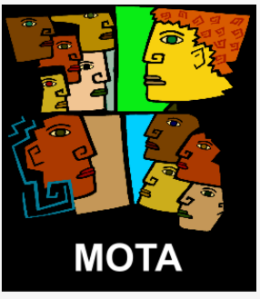
Please share this information
Pre-registration is required.
Sessions are FREE

